RESERVATION FORM

HOTEL IBIS POITIERS CENTRE
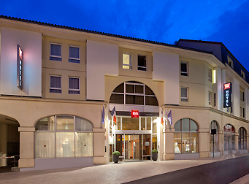
15 rue du petit Bonneveau
86000 POITIERS – France
+ 33 (0) 5 49 61 11 02

Email: H01420@accor.com
Website: ibis.com/fr/hotel-1420-ibis-poitiers-centre/index.shtml
Family Name:
Address:

Phone: / / / / / / - Fax: / / / / / /

E-mail: @
Credit Card Number:

Length of stay at HOTEL IBIS CENTRE

From: (1st night) to (Last night)
Number of nights

Single room | 69.00€
Double room | 69.00€
BREAKFAST | 9.50€
+ Tourist Taxes ~1€ per person per day

Regarding reservations, participants in your event can call directly to Standard Hotel, we present 24h/24 and 7/7 to meet the needs of customers. They can also send their reservations using this form by email H1420@accor.com

Observations:

