RESERVATION FORM


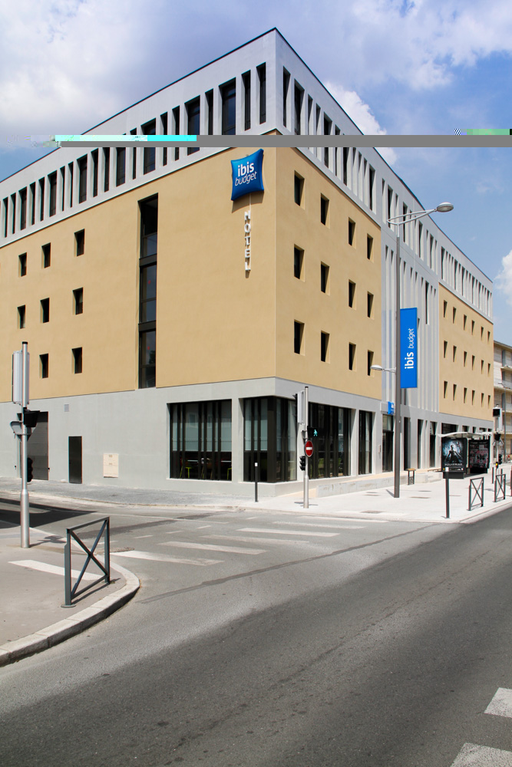
HOTEL IBIS GARE

12 Boulevard de Pont Achard
86000 Poitiers

Email: H9136 @accor.com
Website: ibis.com/fr/hotel-9136-ibis-budget-poitiers-centre-gare/index.shtml

Family Name:
Address:

Phone: / / / / / / - Fax: / / / / / /
E-mail: @
Credit Card Number:

Length of stay at HOTEL IBIS

From: (1st night) to (Last night)
Number of nights

DOUBLE room | 56€*
TWIN ROOM | 56€*
BREAKFAST | 6.15€
* + Tourist Taxes ~0.85€ per person per day

Regarding reservations, participants in your event can call directly to Standard Hotel, we present 24h/24 and 7/7 to meet the needs of customers. They can also send their reservations using this form by email H9136@accor.com

Observations:

